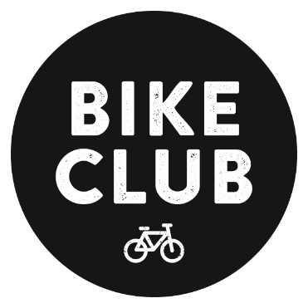

I’M INTERESTED IN BIKE CLUB!

BIKE CLUB:
- teaches students bicycle safety and bicycling skills
- builds self-esteem, inspires healthy lifestyles, and encourages individual responsibility
- is educational and FUN!
- meets once a week after-school from 2:45pm until 4:15pm
- requires students wear closed-toe shoes
- allows students to change into school-appropriate athletic clothes
- rides bicycles on campus and on neighborhood streets
- utilizes the gym if conditions prevent going outside
- provides adult instruction & supervision by faculty and experienced adult cyclists
- requires students wear helmets when on a bike
- encourages walking and biking to school

BIKE CLUB Participation Requirements include…
- 90% school and BIKE CLUB attendance rate – falling below this rate may result in the student no longer participating in BIKE CLUB until attendance improves.
- No F’s on progress report or report card – may result in the student no longer participating in BIKE CLUB until grades improve.
- Behavior Referrals – dealt with on a case-by-case basis and may result in the student no longer participating in BIKE CLUB.

BIKE CLUB is a privilege with the primary goal of educating students so they can ride bicycles safely in their neighborhoods for recreation, fitness, and transportation. Only 20 students will be selected for participation. For more information, visit www.bikeclubtulsa.com.

We understand the expectations outlined above and would like to be considered for participation:
Name of Student (print): ________________________________________________________________
Signature of Parent or Legal Guardian: ____________________________ Date: ___________________

